# (IAM) Identify Access Management

1)Create one IAM user and assign ec2, s3 full access role.

Create one user named as My-IAM and custom password

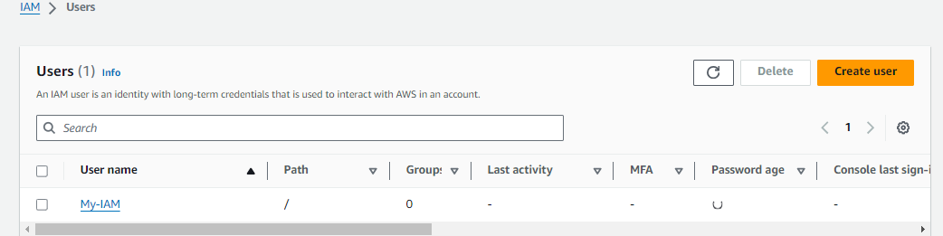

Give the Full access to s3

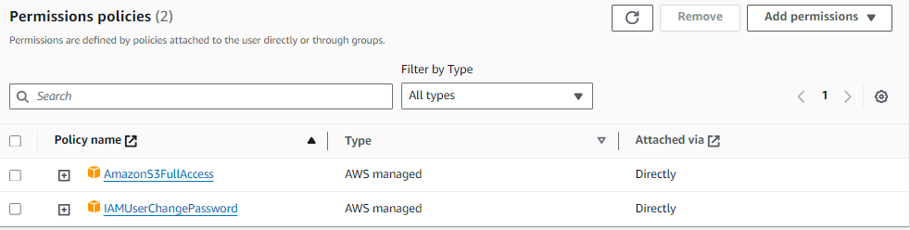

Assign EC2

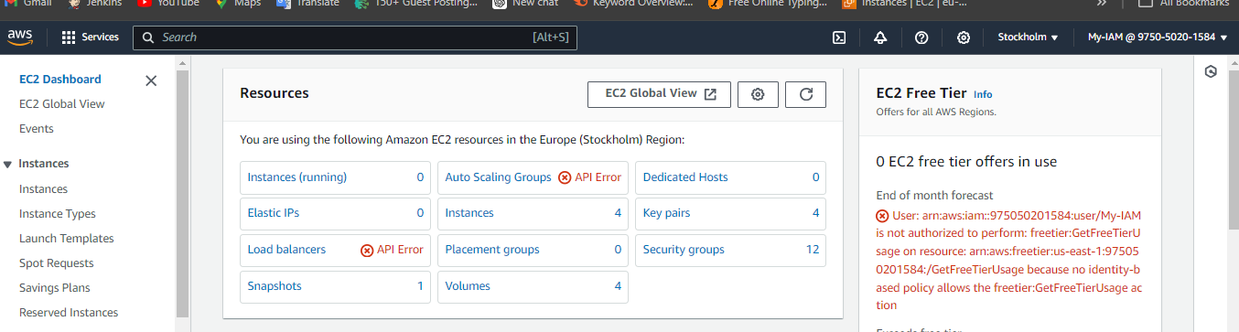

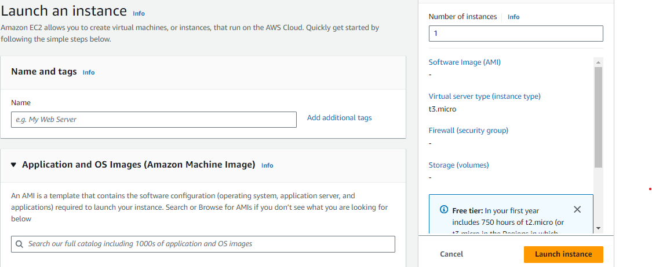

2) Create one Group in IAM and Assign Read access for ec2.

Create one group named as Team-c

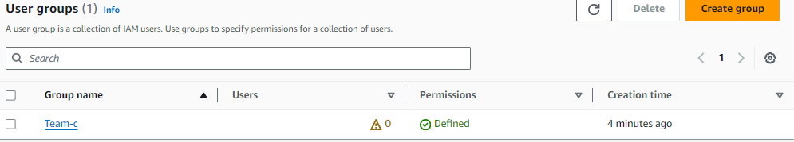

Assign access only read for Ec2

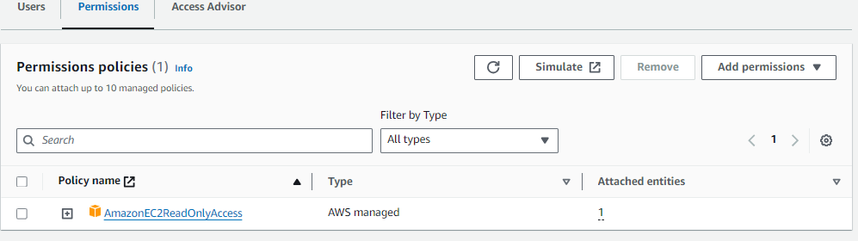

3) Create a new user with name Devops and add to the group created in task2.

Create one user named as Devops

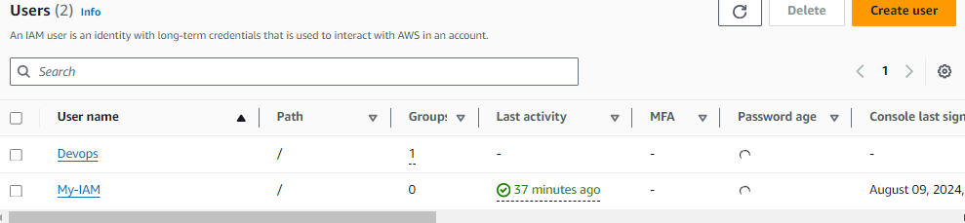

Adding to the group Team-c

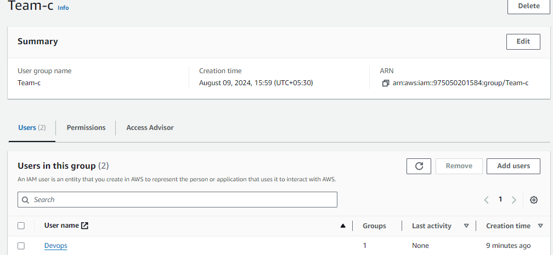

4) Write a bash script to create a IAM user with VPC full access.

Writing a bash script for create IAM user with VPV full access

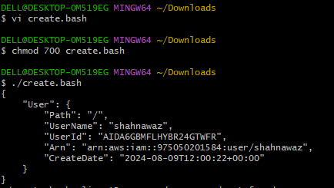

Checking the file user IAM is created or not

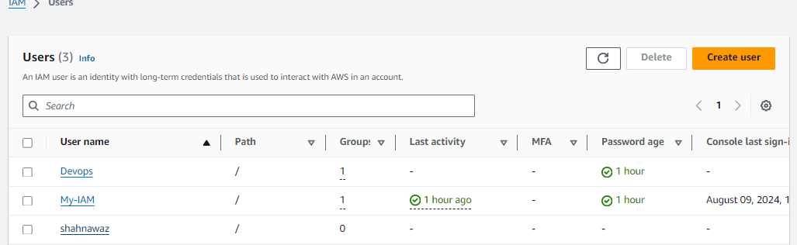

5) Create a IAM policy to access ec2 for a specific user in specific regions only.

Create Policy for access ec2 in specific region

